Fun Dog Show 23rd April 2016
Classes commence at 12.30pm
Classes:
1 | Prettiest Bitch | 12.30 |  | 7 | Best Purebred | 14.30
2 | Handsome Dog | 12.50 |  | 8 | Best Crossbred | 14.50
3 | Best Pair | 13.10 |  | 9 | Young Handler ( under 14yrs) ** | 15.10
4 | Best rehome/rescue | 13.30 |  | 10 | Veteran (over 7 yrs) | 15.30
5 | Puppy Class | 13.50 |  | 11 | Dog the judge wants to take home | 15.50
6 | Most appealing eyes | 14.10

**Young Handler class – handler will be required to complete a short course.
DOG SHOW ENTRY FORM
Entry £1 per class Rosettes to 6th Place
(please write in capitals and complete one form per dog)

Name | Exhibitor Number
Young Handlers Name | Breed
Dogs Name | Age Sex
Please circle classes entered (£1 per class) | 1 2 3 4 5 6
 | 7 8 9 10 11
 | Total due £

I agree to abide by the rules displayed

Signed …………………………………………………….

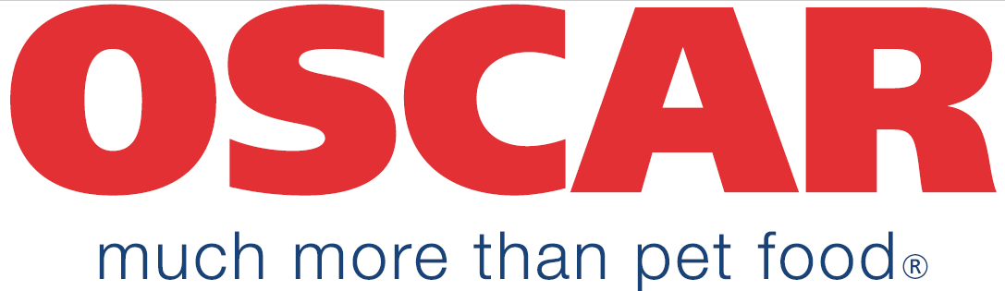
Sponsored by:

